Bijjam, Naresh

Sample Company

Version: 1.0

User manual

4mm Endoscopic Telescope

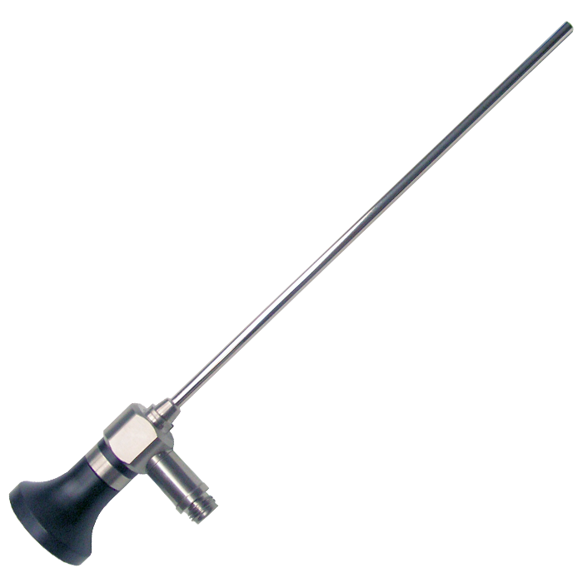

Table of contents

1. Introduction 2

1.1 Product overview 2

1.2 Intended use 2

1.3 Key features 2

1.4 Package contents 2

2. Safety information 3

2.1 General safety precautions 3

2.2 Warnings 3

2.3 Cautions 3

2.4 Symbols used 3

3. Device description 4

3.1 Components 4

3.2 Technical specifications 4

3.3 Compatible accessories 4

4. Instructions for use 5

4.1 Pre-use inspection 5

4.2 Assembly 5

4.3 Intraoperative use 5

4.4 Post-use handling 5

5. Cleaning, sterilization, troubleshooting, and warranty 6

5.1 Cleaning and sterilization 6

5.2 Troubleshooting 6

5.3 Storage 6

5.4 Warranty 6

# 1. Introduction

## 1.1 Product overview

The 4mm Endoscopic Telescope is a high-precision optical instrument designed for minimally invasive diagnostic and surgical procedures. It provides clear, magnified visualization of internal body cavities when used in conjunction with compatible endoscopic systems, including light sources, cameras, and monitors.

## 1.2 Intended use

The 4mm Endoscopic Telescope is intended for use by trained medical professionals in operating rooms, clinics, and hospitals. It is suitable for a variety of endoscopic procedures, including but not limited to laparoscopy, arthroscopy, and cystoscopy.

## 1.3 Key features

* 4mm outer diameter, 30° direction of view
* High-resolution rod lens system
* Autoclavable stainless steel construction
* Universal eyepiece compatible with standard camera heads
* 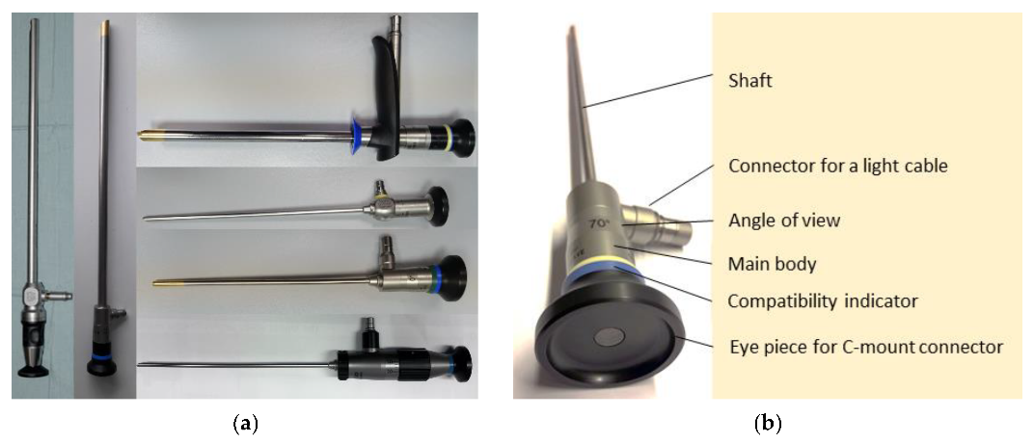Fiber optic light transmission for optimal illumination

## 1.4 Package contents

|  |  |
| --- | --- |
| **Description** | **Quantity** |
| 4mm Endoscopic Telescope | 1 |
| Sterilization tray | 1 |
| Protective lens cap | 1 |
| User manual | 1 |

# 2. Safety information

## 2.1 General safety precautions

* This device is intended for use by qualified medical personnel only.
* Read and understand all instructions before use.
* Inspect the telescope for damage before each procedure.
* Do not use the device if it is damaged or malfunctioning.

## 2.2 Warnings

* Never use the telescope for direct visualization of the sun or strong light sources.
* Do not use the device if the lens is cracked, chipped, or otherwise compromised.
* Ensure all accessories and connections are compatible and properly secured before use.
* Improper cleaning or sterilization may result in patient infection or device damage.

## 2.3 Cautions

* Handle the telescope with care; avoid dropping or striking the device.
* Do not bend or twist the shaft.
* Use only recommended cleaning and sterilization methods.
* Store the device in its protective tray when not in use.

## 2.4 Symbols used

|  |  |  |
| --- | --- | --- |
| **Symbol** | **Safety** | **Description** |
| Warning Symbol | Warning | Risk of injury |
| Common Symbols On A Catheter Package | Sterile | Sterilization required |
| symbol notice sign label on white background 2306672 Vector Art at Vecteezy | Note | Do not autoclave with lens cap attached |

# 3. Device description

## 3.1 Components

1. **Eyepiece:**

Connects to camera head or direct viewing.

1. **Light Post:**

Connects to fiber optic light cable.

1. **Shaft:**

4mm diameter, 175mm length, stainless steel.

1. **Objective Lens:**

30° direction of view, wide-angle.

1. **Distal Tip:**

Insertion end contains lens and light guide.

## 3.2 Technical specifications

|  |  |
| --- | --- |
| **Parameter** | **Specification** |
| Outer Diameter | 4.0 mm |
| Working Length | 175 mm |
| Direction of View | 30° |
| Field of View | 80° |
| Material | Stainless steel, optical glass |
| Sterilization | Autoclavable (134°C, 18 min) |
| Weight | 120 g |

## 3.3 Compatible accessories

* Fiber optic light cables (standard fitting)
* Camera heads (universal eyepiece)
* Endoscopic sheaths and working channels

# 4. Instructions for use

## 4.1 Pre-use inspection

1. Remove the telescope from its tray and inspect for visible damage.
2. Check the lens for cleanliness and integrity.
3. Verify that the light post and eyepiece are free of debris.

## 4.2 Assembly

1. Attach the fiber optic light cable to the light post; ensure a secure fit.
2. Connect the eyepiece to the camera head or direct viewing adapter.
3. Insert the telescope into the appropriate endoscopic sheath or working channel.

## 4.3 Intraoperative use

1. Ensure the light source is on and set to the appropriate intensity.
2. Insert the telescope gently into the body cavity under direct vision.
3. Adjust the camera focus and white balance as needed.
4. Avoid excessive force or angulation during manipulation.

## 4.4 Post-use handling

1. Remove the telescope carefully from the patient and sheath.
2. Disconnect the light cable and camera head.
3. Immediately rinse the device in sterile water to prevent drying of biological material.

# 5. Cleaning, sterilization, troubleshooting, and warranty

## 5.1 Cleaning and sterilization

1. **Manual cleaning:**

Rinse under running water, brush all surfaces with a soft brush, and flush internal channels.

1. **Sterilization:**

Autoclave at 134°C for 18 minutes. Remove lens cap before autoclaving.

1. **Inspection:**

After sterilization, inspect for residual debris, water spots, or damage.

## 5.2 Troubleshooting

Follow the Safety information while troubleshooting.

|  |  |  |
| --- | --- | --- |
| **Problem** | **Possible cause** | **Solution** |
| Image is blurry | Lens is dirty or fogged | Clean lens, allow to acclimate |
| Poor illumination | Light cable not connected or damaged | Check cable and connections |
| Water inside shaft | Seal compromised | Remove from service, contact support |
| Difficulty connecting accessories | Incompatible or damaged parts | Use only recommended accessories |

## 5.3 Storage

* Store the telescope in its sterilization tray with lens cap on.
* Avoid stacking heavy objects on top of the device.

## 5.4 Warranty

The 4mm Endoscopic Telescope is covered by a 2-year limited warranty against defects in materials and workmanship. The warranty does not cover damage due to misuse, improper cleaning, or unauthorized repairs.

For service or support, contact our customer service center at 1-800-555-sample or visit <www.sample.com/support>.